
Solution Architecture

Date | 29 September 2026
Team ID | SWTID-2026-4620
Project Name | Auto Ticket Classification using Flow Designer
Maximum Marks | 5 Marks

Solution Architecture Diagram:
Provide a high-level visual representation of your solution's architecture. Use the structural layout below as a template to map out your Presentation Layer, Application Layer, and Data Layer. Fill in the specific technologies and components for your project directly into the boxes to create your architectural diagram.

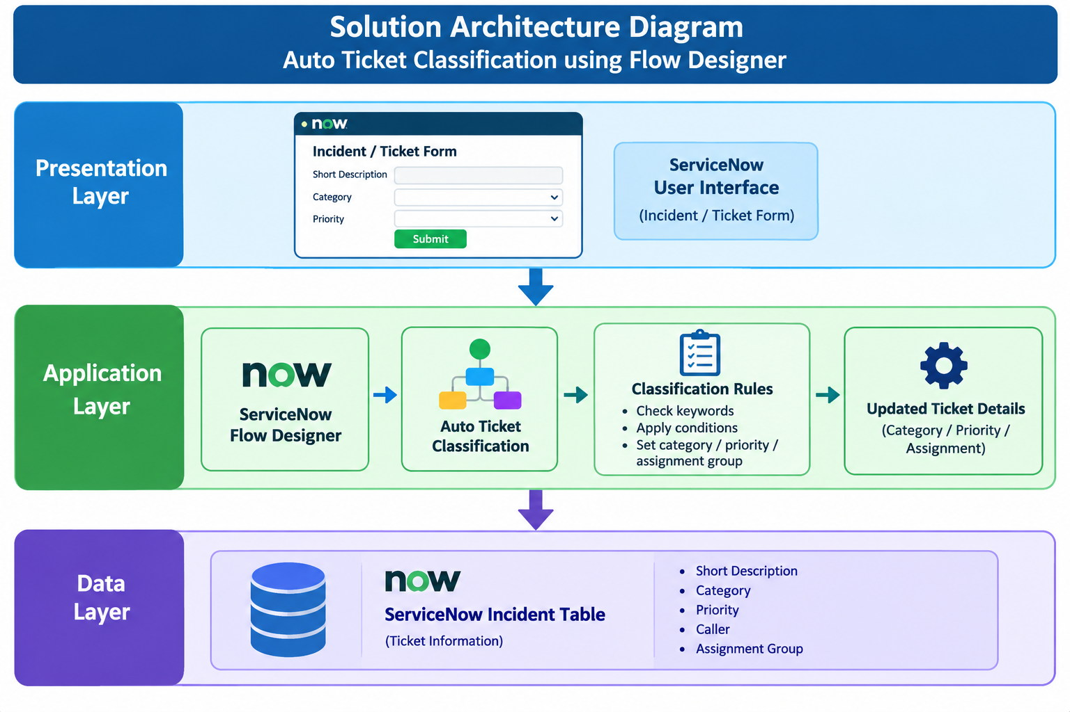

Component Description Table

Component Name | Description / Role in Architecture | Technologies Used
Presentation Layer | Provides the interface for users to create and view support tickets/incidents. | ServiceNow User Interface, Incident Form
Flow Designer | Automatically processes newly created or updated tickets and applies classification rules based on ticket information. | ServiceNow Flow Designer
Auto Ticket Classification | Classifies tickets and automatically sets appropriate ticket details such as category, priority, or assignment group. | Flow Designer, Conditions, Actions
Incident Table | Stores ticket information such as short description, category, priority, caller, and assignment details. | ServiceNow Incident Table
Database | Stores and manages ticket and classification data for future reference and reporting. | ServiceNow Database

